Speaking: Picture Description
Dáme to! Describing and comparing pictures

________________________________________________________
- Look at pictures 1A and 1B. Choose one of the pictures and describe it. The following ideas may help you:

1A

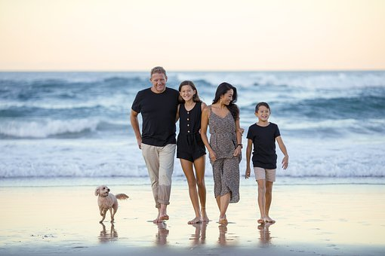
      - Place
- Weather/Season
- People (appearance, clothes…)
- Activities
- Atmosphere
- Other

1B
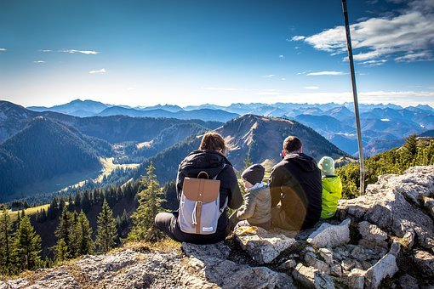

- Look at both pictures once more and compare them (what is similar/the same/different?). The following ideas may help you:
- Place
- Weather/Season
- People (appearance, clothes, etc.)
- Activities
- Atmosphere
- Other

Co jsem se touto aktivitou naučil(a):
………………………………………………………………………………………………………………………………………………………………………………………………………………………………………………………………………………………………………………………………………………………………………

Autor: Lýdie Valešová
Toto dílo je licencováno pod licencí Creative Commons [CC BY-NC 4.0]. Licenční podmínky navštivte na adrese [https://creativecommons.org/choose/?lang=cs].

