Writing: Formal letter
________________________________________________________

- Rád/a byste s přáteli navštívil/a Wales. Na internetu jste našel/našla následující inzerát:
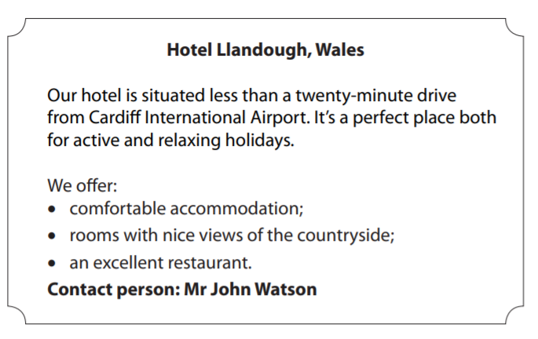

Inzerát vás zaujal, a proto si chcete ubytování v tomto hotelu rezervovat. Napište
panu Watsonovi e-mail v rozsahu 120-150 slov, ve kterém:
- uvedete, odkdy, na jak dlouho, pro kolik osob a jaký typ ubytování si chcete rezervovat;
- se zeptáte, zda je ubytování v tomto termínu možné;
- požádáte alespoň o dvě informace, které jste se z inzerátu nedozvěděl/a.

……………………………………………………………………………………………………………………………………………………………………………………………………………………………………………………………………………………………………………………………………………………………………………………………………………………………………………………………………………………………………………………………………………………………………………………………………………………………………………………………………………………………………………………………………………………………………………………………………………………………………………………………………………………………………………………………………………………………………………………………………………………………………………………………………………………………………………………………………………………………………………………………………………………………………………………………………………………………………………………………………………………………………………………………………………………………………………………………………………………………………………………………………………………………………………………………………………………………………………………………………………………………………………………………………………………………………………………………………………………………………………………………………………………………………………………………………………………………………………………………………………………………………………………………………………………………………………………………………………………………………………………………………………………………………………………………………………………………………………………………………………………………………………………………………………………………………………………………………………………………………………………………………………………………………………………………………………………………………………………………………………………………………………………………………………………………………………………………………………………………………………………………………………………………………………………………………………………………………………………………………………………………………………………………………..........................................................................................................................................................................................................................................................................................................................................................................................................................................................................................................................................................................................................................................
Co jsem se touto aktivitou naučil(a):
………………………………………………………………………………………………………………………………………………………………………………………………………………………………………………………………………………………………………………………………………………………………………

Autor: Lýdie Valešová
Toto dílo je licencováno pod licencí Creative Commons [CC BY-NC 4.0]. Licenční podmínky navštivte na adrese [https://creativecommons.org/choose/?lang=cs].

